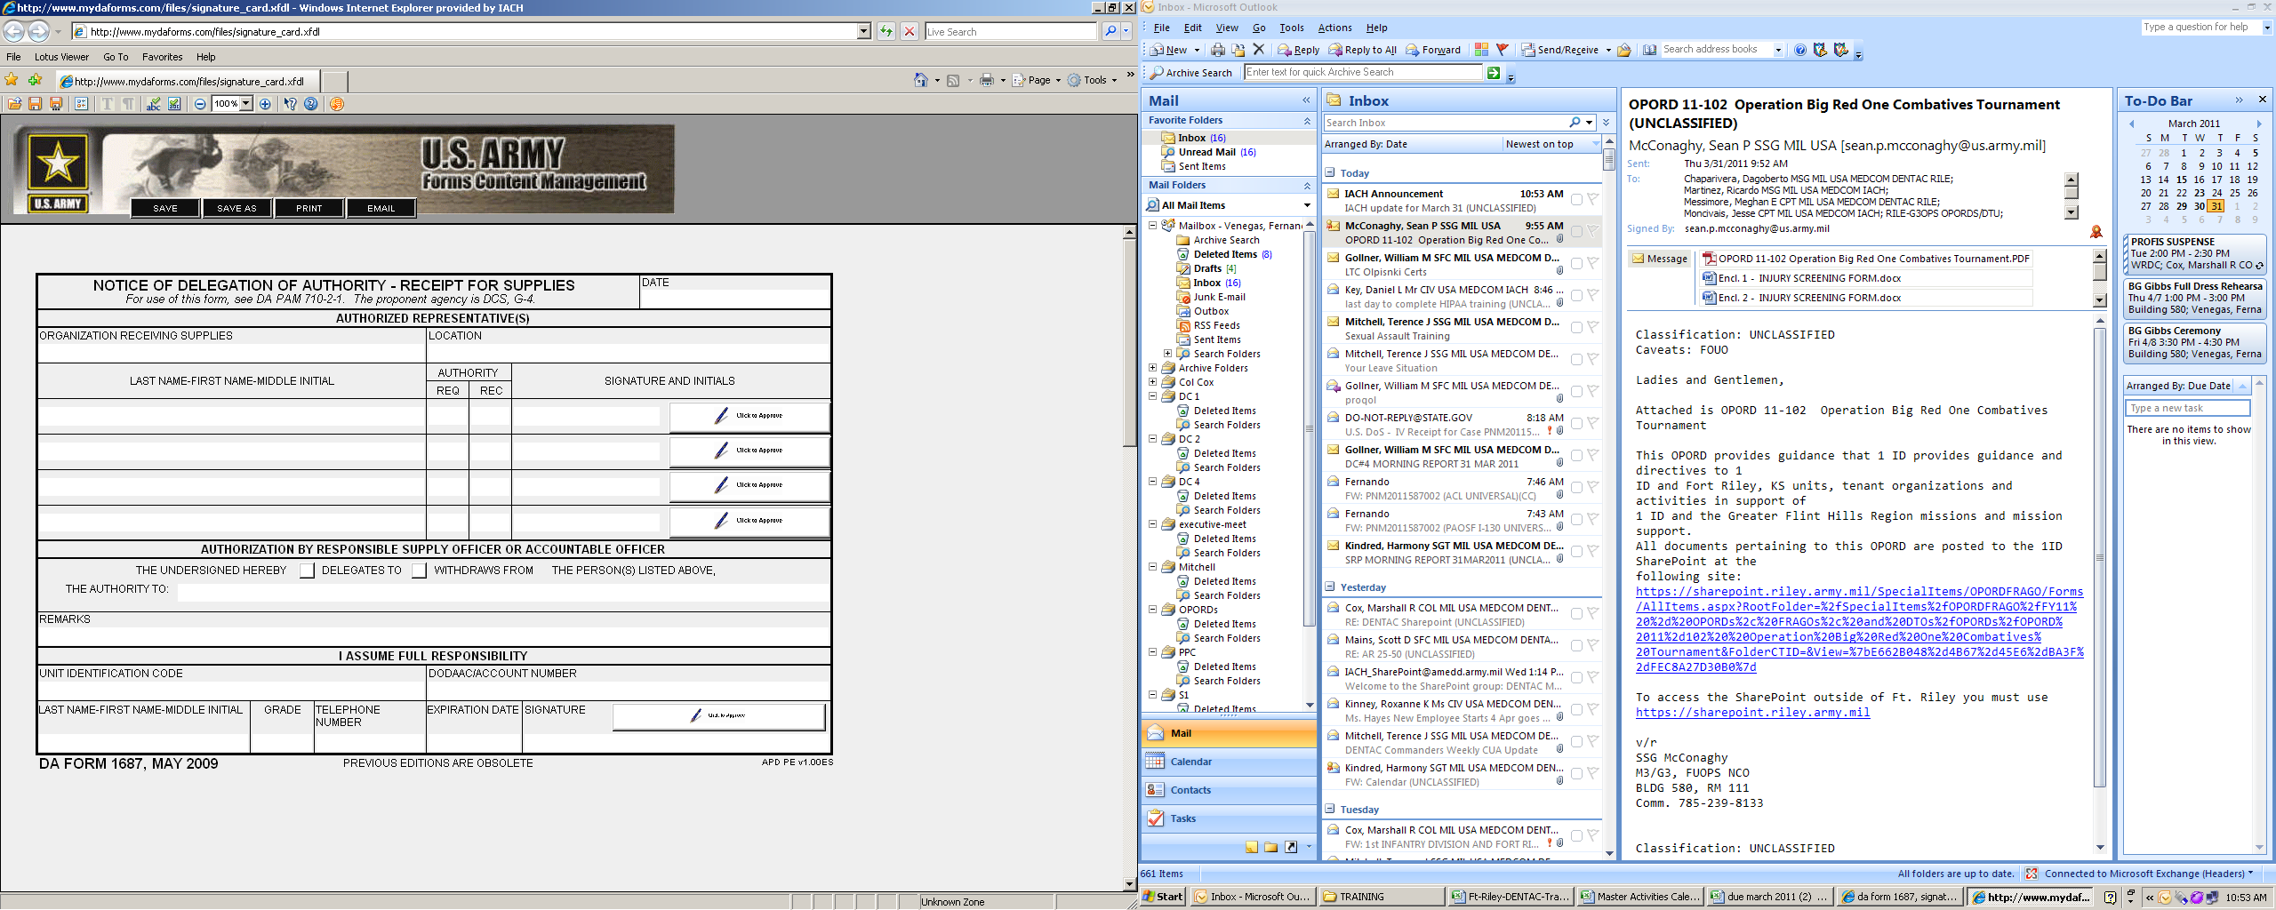
31 MAR 11
Your info
Name goes here
Your info
Your info
Your info
Your info
Your Unit
Your info
Your UIC
Your info
Your info
Your #
30 MAR 12
O3

X
X
X
X
X
X
X
X
X
X

Your Unit

