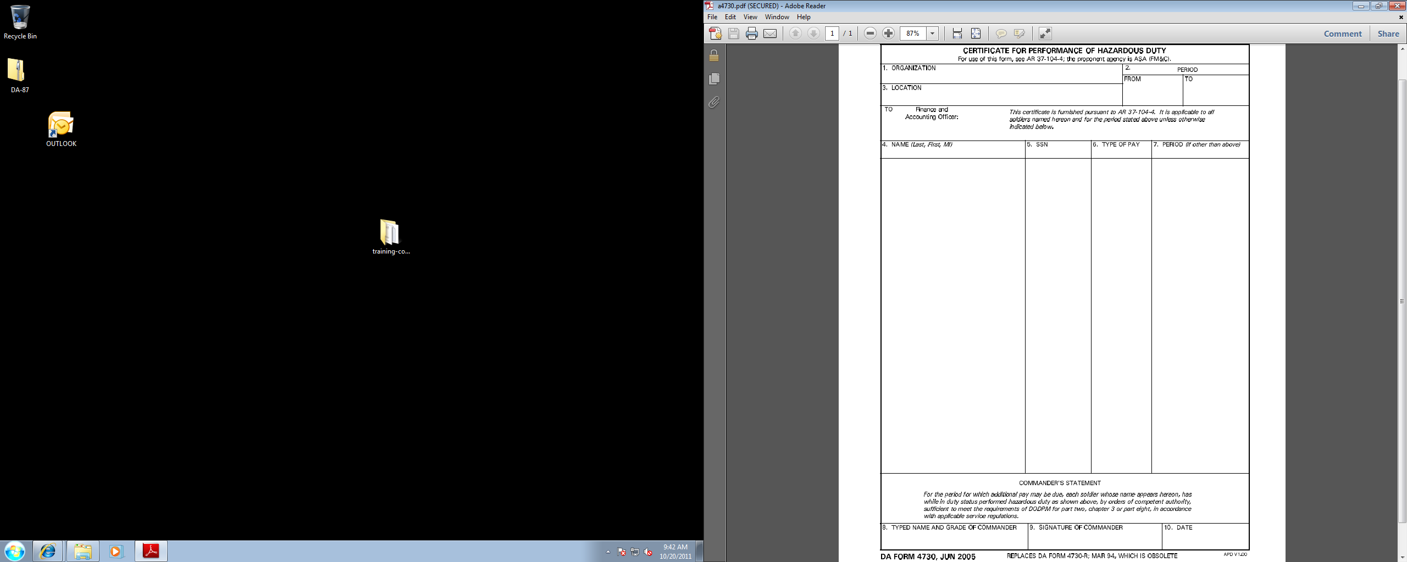
Your info here
Your info here 123-45-6789 add add

Your info here
Your info here
Your info here
20111021
20111021
20111021

