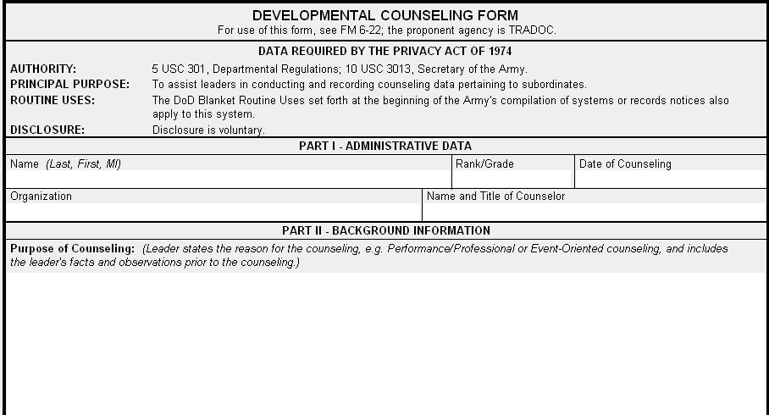
Bush, George, W SPC/E4 19 January 2011
69th Military Police BN Bobby Brown, SGT, Squad Leader
Write Here>>
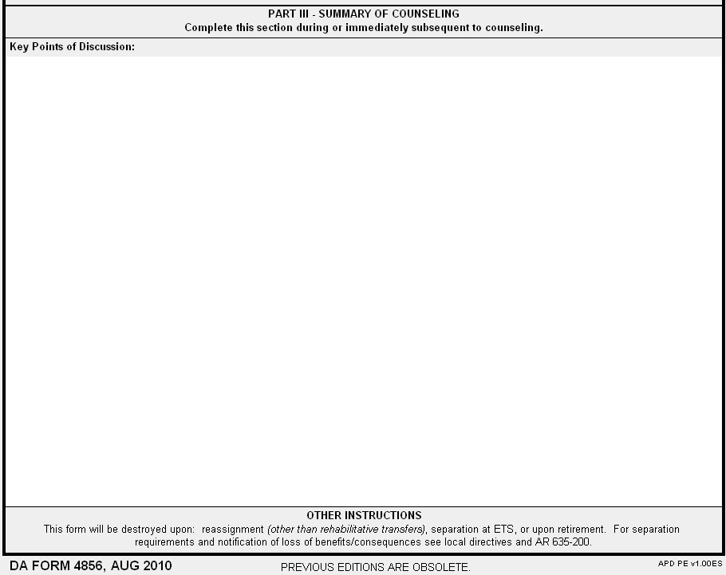
Write Here >>>
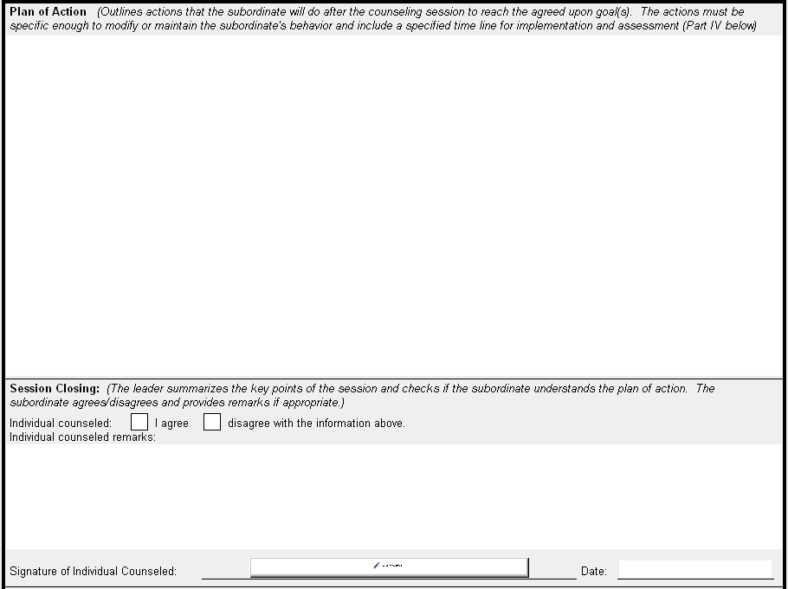
Bush, George, W
Write Here>>
Write Here >>
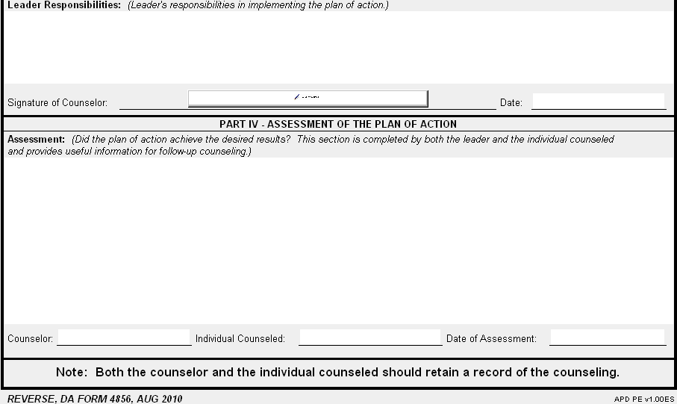
Bush, George, W

